Pancakes
Prep time 5 min Cook time 15 min
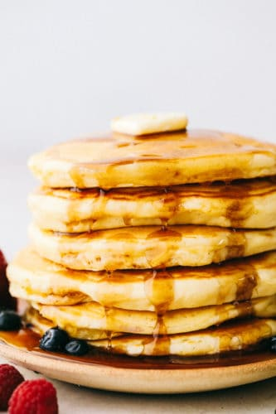
4 Servings
Ingredients
1 egg
2 tbsp oil
1 cup milk
1 cup flour
¼ tsp salt
2 tbsp sugar
2 tbsp baking powder
Directions
- In a medium sized bowl whisk together egg, oil and milk.
- In a separate bowl combine flour, salt, sugar and baking powder.
- Add the dry ingredients into the wet ingredients and combine.
- Preheat a skillet over medium heat. Spray with cooking spray and drop about 1/3 cup of the batter onto the warm skillet. Once it forms bubbles then flip to the other side and cook until golden brown.

